Project Design Phase-II Data Flow Diagram & User Stories
Date  Team ID  Project Name  Maximum Marks | 30 June 2025  LTVIP2025TMID49757  Visualization Tool for Electric Vehicle Charge and Range Analysis 4 Marks
Data Flow Diagrams:
A Data Flow Diagram (DFD) is a traditional visual representation of the information flows within a system. A neat and clear DFD can depict the right amount of the system requirement graphically. It shows how data enters and leaves the system, what changes the information, and where data is stored.
Example: DFD Level 0 (Industry Standard)
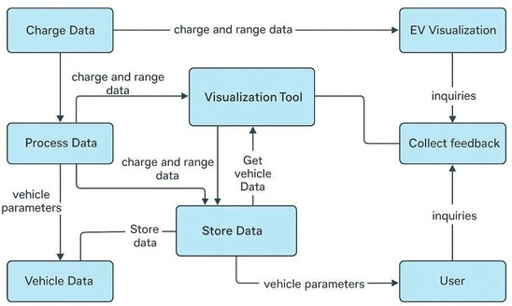
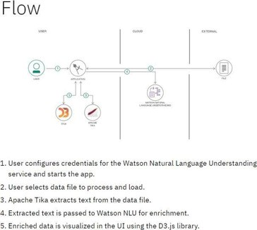
Example: (Simplified)
User Stories
Use the below template to list all the user stories for the product.
User Type | Functional  Requirement  (Epic) | User Story  Number | User Story / Task | Acceptance criteria | Priority | Release
\EV Owner  (Mobile user) | Account  Management | USN-1 | As an EV user, I want to register and log in to the app to securely access personalized features | anUser can create  account and sign in using valid credentials | High | Sprint-1
 | Map Visualization | USN-2 | As a user, I want to view a map showing nearby charging stations and range zones | Map loads with charging station icons and vehicle  range overlay | High | Sprint-1
 | Vehicle Charge Analysis | USN-3 | As a user, I want to input my vehicle’s battery level and get real-time range estimates | System provides accurate range estimates  based on battery and  driving data | Low | Sprint-2
 | Charging History | USN-4 | As a user, I want to view my previous charging sessions and performance reports | App displays historical charts and statistics about past charges | Medium | Sprint-2
Admin | Data  Management | USN-5 | As an admin, I want to upload and manage station data across different locations | Admin panel shows options add/updateto information station  Dashboard reports include | High | Sprint-1
 | User Monitoring | USN-6 | As an admin, I want to monitor system usage and user activity for improvement tracking | session logs and activity summaries | Medium | Sprint-3

Data Analyst Reporting Module USN-7
Guest User Demo Access USN-8 As an analyst, I want to generate customized reports based on station usage and range patterns
As a guest, I want to explore the tool in demo mode without signing up
As an analyst, I want to Medium Sprint-3
generate customized reports based on station usage and range
patterns
Demo mode provides Low Sprint-2 limited but working
sample visualizations

